3.8.6 - Editors - Properties Editor - Object Tab
Object Tab 2
Object Edit Box 3
Transform Panel 3
Location 3
Rotation 3
Scale 3
Lock 3
Animate Properties 3
Rotation Mode 4
Delta Transform 4
Delta Location 4
Delta Rotation 4
Delta Scale 4
Lock 4
Animate Properties 4
Relations Panel 4
Parent 5
Parent Type 5
Slow Parent 5
Tracking Axis 5
Up Axis 5
Pass Index 5
Animate Properties 5
Collections Panel 5
Add to collection 6
Add Collection 6
Collection 6
Collection Name 6
Remove 6
Collections Menu 6
Offset 6
Duplication Panel 6
None 7
Dupliframes 7
Workflow with follow frame: 7
Workflow as an array tool: 8
DupliFrames Tools 8
Start 8
End 8
On 8
Off 8
Display Dulipcator 9
Render Duplicator 9
Dupliverts 9
Workflow: 9
Dupliverts Tools 10
Display Dulipcator 10
Render Duplicator 10
Rotation 10
Dupliface 10
Workflow: 10
Dupliface Tools 11
Scale 11
Inherit Scale 11
Display Dulipcator 11
Render Duplicator 11
Animate Properties 11
Motion Paths Panel 11
Workflow: 12
Motion Paths Tools: 12
Paths Type 12
In Range 12
Paths range update 12
Around Frame 12
Cache From and To 13
Update Paths 13
Delete Paths 13
Display 13
Viewport Display Panel 14
Name 14
Wireframe 14
Texture Space 14
In Front 14
Axis 14
All Edges 15
Shadow 15
Display As 15
Bounds 15
Color 15

Object Tab

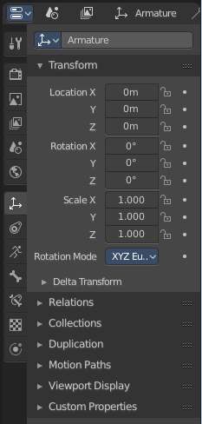
The Object tab contains all general object related settings like Transform, Relation or Collection related things. It is the same for all object types and in all modes.

Object Edit Box
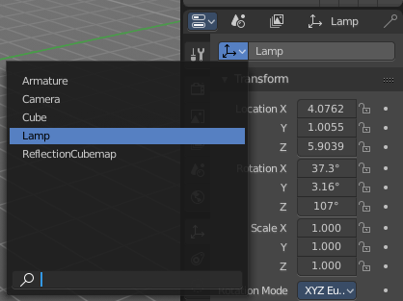
Here youcan read what object is currently selected. Here you can also choose another object in the list at the left.. And you can rename the object.

Transform Panel
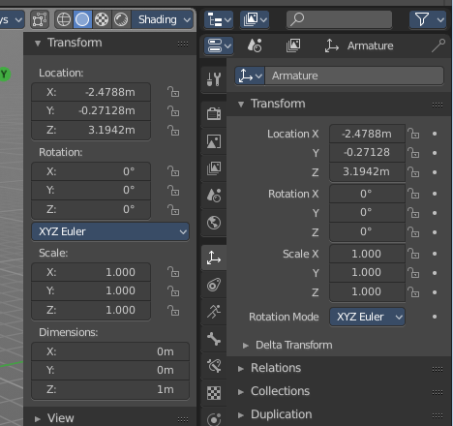
Transform is position, rotation and scale of the object. It is partially the same content that you see in Object mode in the Properties sidebar in the 3D view.

However, when you switch to Edit mode, with a Bone for example, then you will still have the overall world transform values for the object here, while the Transform paneln in the Properties sidebar now displays the edit transform values for the bone.

Location
The location of the object.

Rotation
The rotation of the object.

Scale
The scale of the object.

Lock
This properties can be locked.

Animate Properties
This properties can be animated. Activating the Animate Property button sets a keyframe.

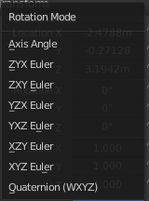
Rotation Mode
The rotation mode. Euler angles are fine for most needs. But sometimes you want to use Quaternion to avoid gimbal lock. Gimbal lock is a mathematical problem where the rotation locks up in two instead of three degrees of freedom.

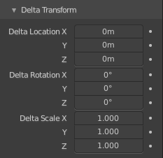
Delta Transform
Transforms are absolute to the world coordinates. Delta Transforms are relative to the current transformation.
Here you can adjust the delta transforms.

Delta Location
The delta location of the object.

Delta Rotation
The delta rotation of the object.

Delta Scale
The delta scale of the object.

Lock
This properties can be locked.

Animate Properties
This properties can be animated. Activating the Animate Property button sets a keyframe.

Relations Panel

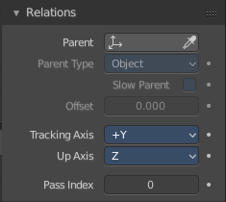
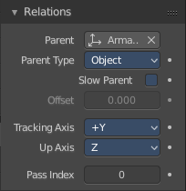
Here you can set up and adjust relations for the object.

Parent
Here you can set a parent object. One way is by the object picker at the right. Or choose the object in the list. This list appears by clicking at the edit box.

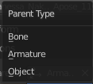
Parent Type
Here you can see and set the parent type.

Slow Parent
Create a delay in the parent relationship.
This feature is not renderfarm save. And may become invalid after jumping around the timeline.

Offset
The offset for slow parent.

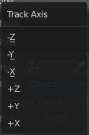
Tracking Axis
The axis that points in forward direction.

Up Axis
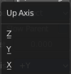
The axis that points in the up direction.

Pass Index
The index number for the "Object Index" render pass.

Animate Properties
This properties can be animated. Activating the Animate Property button sets a keyframe.

Collections Panel

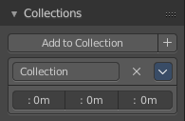
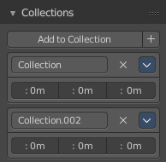
Collections is a bunch of data, objects, cameras, lights, etc. , which you can manage in some ways at once. You can for example hide complete collections, include or exclude it from rendering, instance them, and so on.

An object must be at least in one collection. Or it gets deleted. But an object can be in multiple collections. Here you can manage in what collection(s) the object is.
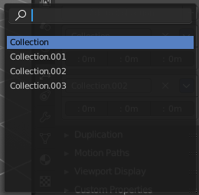

Add to collection
A dropdown box where you can choose the collection that you want to add the object to.

Add Collection
At the end of the Add to Collection element is a + button where you can add more collections.

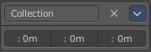
Collection
This is the collection where the object is currently assigned at. As told, an object can be assigned to more than one collection.

Collection Name
Here you can read and edit the collection name

Remove
This deletes the collection from the object. Note that the collection still exists.

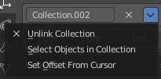
Collections Menu

Unlink Collection
This deletes the collection from the object. Note that the collection still exists.

Select Objects in Collection
Selects all objects in the collection.

Set Offset From Cursor
Set offset used for collection instance based on cursor position. (Narp, i don't understand this neither. Waiting for the Blender manual here ...)

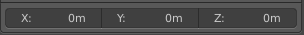
Offset
Offset from the origin to use when instancing.

Duplication Panel

Here you find settings for Dupliframes, Dupliverts and Dupliface. They require a special setup each.

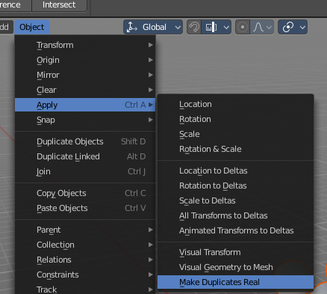
The duplicated geometry by this method are instances of the mother object. And so they cannot be treaten like real objects.

To turn them into editable geometry go to Object menu, and choose Apply / Make Duplicates real.

None
No duplication happens.

Dupliframes
Note that this tool is currently broken! And does not work as expected. Waiting for a fix.
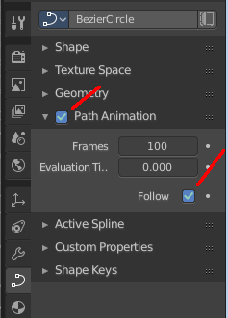
DupliFrames is a tool to duplicate objects at frames distributed along a path.

Workflow with follow frame:
Create a bezier curve. In its Object Data tab tick Path Animation, tick Follow, and set the frames to whatever you need.

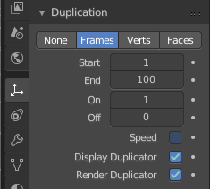
Create a cube. In its duplication panel tick Frames. And disable Speed.

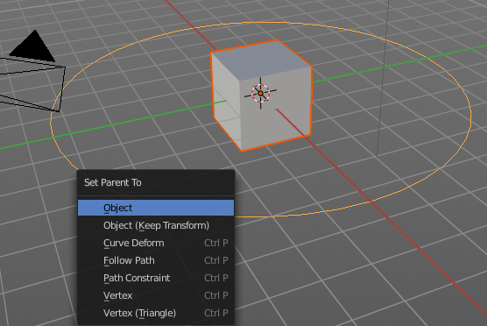
Now parent the Cube to the Bezier Curve.

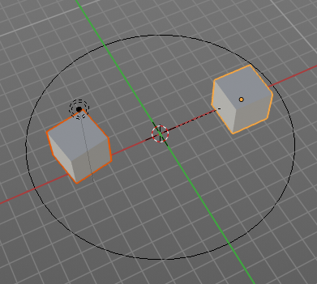
You will notice that you will have a second cube now. An instance. When you shrub the time line, then this instanced cube will move. The position of the original cube relative to the circle is important to determine the position and movement of the instance.

Workflow as an array tool:
Create a bezier path. Tweak it to your needs.
Parent the cube to the path.
In the Duplication panel, tick Frames, and untick Speed. This should give you already a result.
As told above, this tool is currently broken.

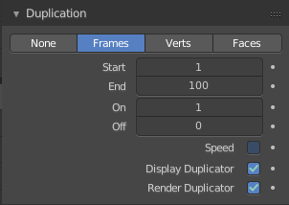
DupliFrames Tools

Start
Start Frame for Dupliframes.

End
End Frame forDupliframes.

On
Number of Frames to use between DupOff Frames.

Off
Recurring frames to exclude from the dupliframes. With 100 frames and 20 off you will have 5 instances.
Example for on off. Lets say you have on with 4 and Off with 20. With 100 frames and 20 off you will have 5 instances as told above. And On 4 produces four extra instances here for each of this 5 instances. So we have 20 in the end. Distributed as shown below.
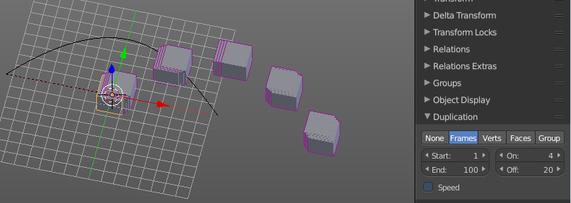

Display Dulipcator
Duplicator is our parent object, the cube. Display the duplicator in the viewport.

Render Duplicator
Duplicator is our parent object, the cube. Render the duplicator.
Note that the child object in the center will always render. This one can't be turned off.

Dupliverts
DupliVerts is the duplication of a base object at the location of the vertices of a mesh. In other words, an instance of the base object is placed on every vertex of the mesh.

Workflow:
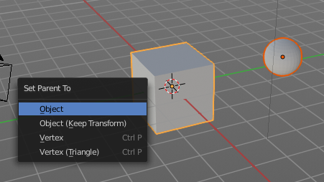
Create a cube, create a sphere. For demonstration purposes, move the sphere a bit off. Parent the sphere to the cube ( select sphere, hold down shift, select cube, press ctrl p). Cube must be the parent, sphere the child.

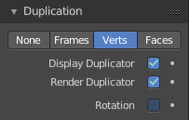
Select just the cube. In the Duplication Panel enable Verts.

As a result you will now have eight spheres around the childsphere, since the cube has eight vertices. The center point is the sphere.
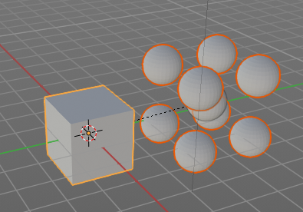

Dupliverts Tools

Display Dulipcator
Duplicator is our parent object, the cube. Display the duplicator in the viewport.

Render Duplicator
Duplicator is our parent object, the cube. Render the duplicator.
Note that the child object in the center will always render. This one can't be turned off.

Rotation
Without rotation the instances points all into the initial direction of the parent object. With rotation they point away from parent object.

Dupliface
DupliFaces replicates an object on each face of a parent object, using the initial child object as the center. The faces of the parent object is the pattern that gets used as the pattern to create the duplicated objects. The child object gets used as the center point, and of course to duplicate the geometry from.

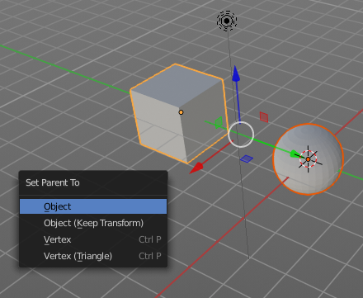
Workflow:
Create a cube, create a sphere. Move the cube a bit off. Parent the sphere to the cube ( select sphere, hold down shift, select cube, press ctrl p). Cube must be the parent, sphere the child.

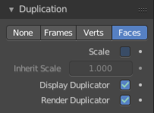
In the Duplication Panel enable Faces.

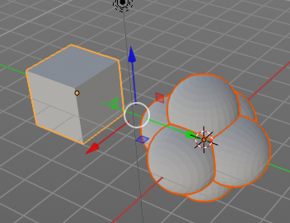
As a result you will now have six spheres at the childsphere, since the cube has six sides.

Note
The location, orientation, and scale of the duplicated child(ren) matches that of the faces of the parent. So, if several objects are parented to the cube, they will all be duplicated once for each face on the cube. If the cube is subdivided, every child will be duplicated for each face on the cube.

Dupliface Tools

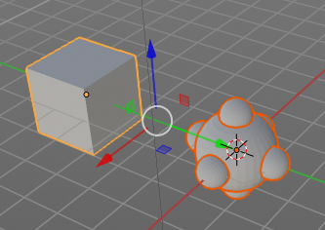
Scale
When you tick scale then you can control the size of the child objects.

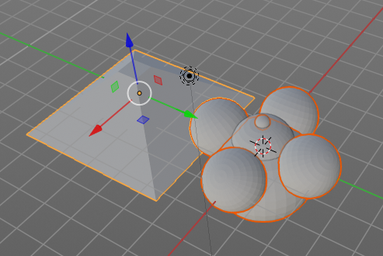
With Scale ticked you can also influence the size of the child objects by changing the parent geometry.

Inherit Scale
The scale factor for scale.

Display Dulipcator
Duplicator is our parent object, the cube. Display the duplicator in the viewport.

Render Duplicator
Duplicator is our parent object, the cube. Render the duplicator.
Note that the child object in the center will always render. This one can't be turned off.

Animate Properties
This properties can be animated. Activating the Animate Property button sets a keyframe.

Motion Paths Panel
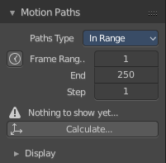
Motion paths is a visual helper to judge the motion of objects.

Motion paths are not displayed by default. They need to be calculated. This can be done here.

Workflow:
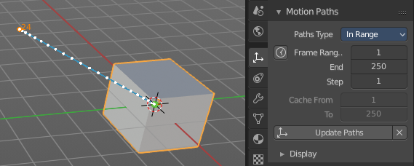
We simply need a motion animation first. For example a moving cube.

Add a cube. Chooose a keying set. Set a keyframe at let's say frame 0. Go to frame 24. Move the object. Set a keyframe at frame 20.

Click Calculate. You will now see the motion path of this objet.

Motion Paths Tools:

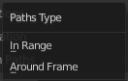
Paths Type
There are two path types available.

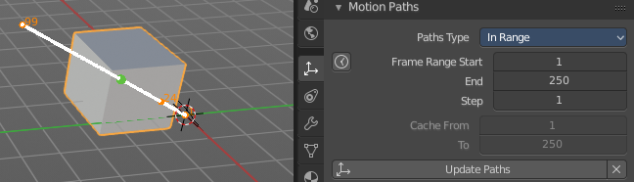
In Range
Displays the full range of the motion path.

Paths range update
Update Frame Range for Motion paths from the scene's current frame range.

Frame Range Start
The start frame.

End
The end frame.

Step
Number of frames between paths shown.

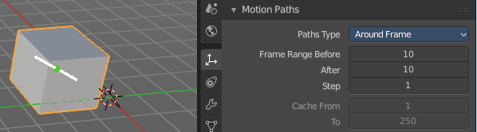
Around Frame
Displays just the motion path around the current frame. Not the whole path.

Frame Range before
The frames to display before the current frame.

After
The frames to display after the current frame.

Step
Number of frames between paths shown.

Cache From and To
Not editable. Internal cache information that should be hidden.

Update Paths
Update the paths after any changes at the animation. You have to update the paths too if you change settings like the paths type.

Delete Paths
Deletes ALL motion paths caches in the scene. Hold down shift to delete just the path for the current object.

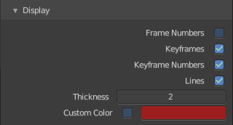
Display
Here you find some display options for the path.

Frame Numbers
Display the frame number above every knot of the motion path

Keyframes
Display the keyframes in the path as orange dots.

Keyframe Numbers
Display the keyframe number above every keyframe.

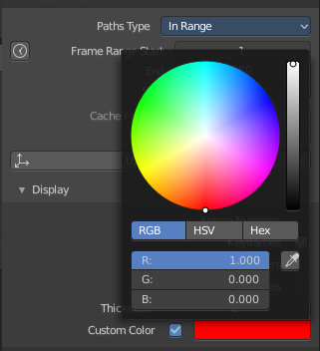
Lines
Display a line between the points.

Thickness
The line thickness.

Custom Color
Here you can define a custom color for the motion path. A click at the color area opens a color picker.

Viewport Display Panel

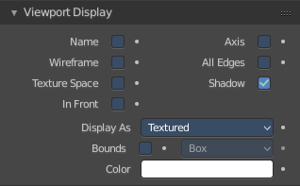
Here you will find some further display options for the object. Object name, Wire Frame in Object Mode, etc.

Some of these settings will override general settings. For example when you set the maximum draw type (Display as) to Wire, then it will always display as wire, regardless if you set the Viewport render method to Material or Textured.

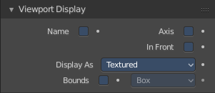
The content is different for different object types. Mesh objects have more display options than a bone for example.

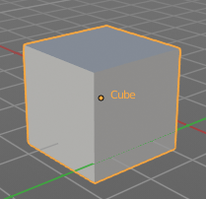
Name
Display the object name at the pivot point.

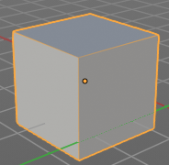
Wireframe
Display parts of the wireframe in Object Mode. See All Edges.

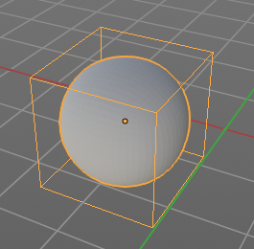
Texture Space
Display the objects texture space. This has to do with the mapping. A sphere can for example have a cubic mapping.

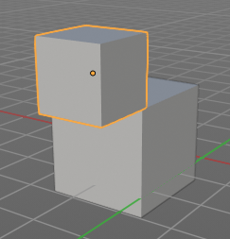
In Front
X Ray. Display this object in front of all other objects.

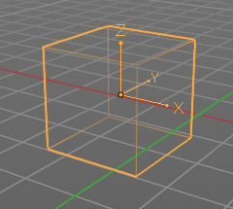
Axis
Display the objects axis. Best done with Wireframe display mode. Solid faces may hide the axis. Or tick in Front. Then the axis gets also drawn above the mesh faces.

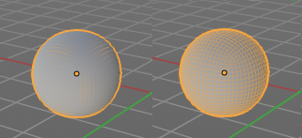
All Edges
This is a hieronymus bosch feature from Blender developers that will most probably trap you again and again. When you tick Wireframe then SOME of the edges of the object gets displayed. You need to tick all edges to display the whole Wireframe.

Shadow
The object should throw a shadow in the 3D view.
Broken Feature.

Display As
Here you can adjust the maximum display method for the object. For example when you set the maximum draw type to Wire, then it will always display as wire, regardless if you set the Viewport render method to Material or Textured.

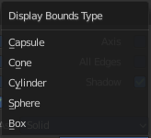
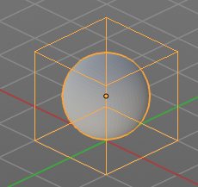
Bounds
Display the bounding box for this object. And you can choose what shape to choose. There is more than just the classical box shape available.

Color
Object Color and Alpha that is used when Faces have the ObColor Mode enabled.
No idea where that gets enabled. Thanks Blender Devs!

Custom Properties Panel


Here you can define custom properties that can be used for scripting.

Here you might also find custom properties from addons or scripts.

Add
Adds a new property.


Edit
A panel where you can adjust the settings for the custom property.

Remove
Removes the property.

